

NPTEL Online Certification Course
Industrial Engineering and Operations Research
Assignment Number 10: Detailed Solution
Indian Institute of Technology Guwahati

Q.1. Critical path corresponds to the
(A) shortest time path through the network
(B) longest time path through the network
(C) path with the most activities
(D) path with the maximum float
Sol. The longest time path computed through the network is called critical path. It consists of activities with zero total float. It defines the minimum project completion time. Monitoring critical path activities is essential for timely project completion. Hence, option (B) is correct.
Q.2. Critical Path Method (CPM) was developed in
(A) 1930s (B) 1940s (C) 1950s (D) 1970s
Sol. Critical Path Method was developed in the late 1950s by Morgan R. Walker of DuPont and James E. Kelley Jr of Ramington Rand, independently. Hence, option (C) is correct.
Q.3. A project consists of the following activities and durations:

Activity | Predecessor(s) | Duration (days)
A | — | 4
B | A | 3
C | A | 2
D | B, C | 4
E | D | 5

For activity D, (earliest start, earliest finish, latest start, latest finish) times (in days) are
(A) (7, 11, 7, 12) (B) (7, 11, 7, 11) (C) (5, 10, 7, 12) (D) (5, 12, 7, 12)
Sol. Forward pass is used to determine the earliest start (ES) and earliest finish (EF) times for each activity:
Activity A: ES = 0, EF = ES + duration = 0+4 = 4
Activity B: ES = EF of A = 4, EF = 4+3 = 7
Activity C: ES = EF of A = 4, EF = 4+2 = 6
Activity D: ES = max. (EF of B, EF of C) = max. (7, 6) = 7, EF = 7+4 = 11
Activity E: ES = EF of D = 11, EF = 11 + 5 = 16
Project finish time is 16 days.
Backward pass is used to determine the latest start (LS) and latest finish (LF) times for each activity:
Activity E: LF = project finish time = 16, LS = 16−5 = 11
Activity D: LF = LS of E = 11, LS = 11−4 = 7
For activity D, earliest start, earliest finish, latest start, latest finish is 7, 11, 7 and 11 days, respectively. Hence, option (B) is correct.
Q.4. A project consists of 14 activities, A to N. The duration of activities in weeks are shown in the brackets in the network diagram.

The minimum duration of the project is
(A) 14 weeks (B) 18 weeks (C) 19 weeks (D) 20 weeks
Sol. Different activities of the project and time duration are shown in Table.

Activities | Time duration (weeks)
A→B→E→M→N | 3+2+4+3+2=14
A→C→F→J→K→L→N | 3+4+2+2+3+2+2=18
A→C→G→I→L→N | 3+4+4+5+2+2=20
A→D→H→L→N | 3+2+4+2+2=13
The minimum duration of the project is determined by the longest path through the network which is also known as the critical path. The activities on the critical path is A→C→G→I→L→N and time duration is 20 weeks. Hence, option (D) is correct.
Q.5. A project can be completed after the completion of activities P (duration: 12 days) and Q (duration: 14 days). Earliest starting dates of P and Q are April 12, 2026 and April 8, 2026, respectively. The project will be completed on
(A) April 23, 2028 (B) April 24, 2026 (C) April 22, 2026 (D) April 21, 2026
Sol. Activity P starts on April 12, 2026 and duration is 12 days. Hence, activity P finishes on April 23, 2026. Activity Q starts on April 8, 2026 and duration is 14 days. Hence, activity Q finishes on April 21, 2026. To estimate the completion date, it needs to be ensured that both the activities of the project are completed, i.e., April 23, 2026. Hence, option (A) is correct.
Q.6. It is planned to launch a smart fitness device in the market. Total 7 activities are needed as per the following table:

Activity | Description | Predecessor
A | Market survey | ---------------------
B | Design | A
C | Market strategy | A
D | Design of production facility | C
E | Selection of advertising method | B
F | Prototype testing | D, E
G | Launching | F
The suitable network diagram is

(A)
(B)

(C)

(D)

Sol. In option (A), predecessor of activity D is shown as B which is incorrect. In option (B), the network diagram correctly corresponds to the activities. In option (C), predecessor of activity D is shown as B and the predecessor of activity G is incorrectly represented as E and F. In option (D), activity E is represented as dummy, which is incorrect. Hence, option (B) is correct.
Q.7. Immediate predecessor of activities B (duration: 7 days) as well as C (duration: 6 days) is activity A. Latest finish times of activities B and C are 12 and 17 days, respectively. Latest finish time of activity A is
(A) 4 days (B) 5 days (C) 12 days (D) 11 days
Sol. Activity A is the immediate predecessor of both B and C (i.e., A → B and A → C). The latest finish (LF) of the successors (B and C) determine the latest allowable finish of A.
Duration of activity B = 7 days, LF of B = 12 days
Duration of activity C = 6 days, LF of C = 17 days
The latest start (LS) of activities B and C is evaluated:
LS of B = LF of B – duration of B = 12–7=5 days
LS of C = LF of C – duration of C = 17–6=11 days
A must finishes no later than the earliest latest-start among its successors
LF of A = min (LS of B, LS of C) = min (5,11) = 5 days
Hence, option (B) is correct.
Q.8. A project comprises 5 activities as listed in the table.

Activity | Predecessor | Duration (days)
A | - | 2
B | A | 4
C | A | 7
D | B, C | 5
E | C | 3

The critical path and the project's minimum completion time are
(A) Critical Path: A-B-D, Minimum time: 10 days
(B) Critical Path: A-C-D, Minimum time: 14 days
(C) Critical Path: A-C-E, Minimum time: 12 days
(D) Critical Path: A-B-D, Minimum time: 9 days
Sol. The network diagram of the project is shown in Figure.
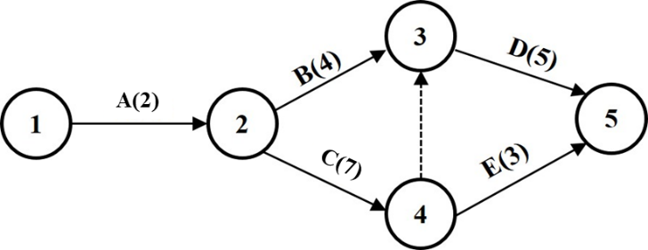
The minimum duration of the project is determined by the longest path through the network which is also known as the critical path. The duration of each possible path is calculated:
A→B→D=2+4+5=11 days,
A→C→D=2+7+5=14 days,
A→C→E=2+7+3=12 days
The path containing activities A, C and E has the longest duration, i.e, 12 days. Hence, option (B) is correct.
Q.9. An activity has duration D. Its earliest start time is x and latest start time is y. Its earliest completion and latest completion times are
(A) (x+D) and (x−D), respectively (B) (x−D) and (x+D), respectively
(C) (x+D) and (y−D), respectively (D) (x+D) and (y+D), respectively
Sol. Earliest finish is estimated as
EF = ES + duration
Latest finish is estimated as
LF= LS + duration
Hence, option (D) is correct.
Q.10. The earliest and latest occurrence times of event 1 are 2 days. The earliest and latest occurrence time of event 3 are 8 and 11 days, respectively. Total float (TF) and free float (FF) of activity 1-3 (duration: 4 days) are
(A) TF= 5 days, FF= 2 days (B) TF=6 days, FF=3 days
(C) TF=2 days, FF=2 days (D) TF=4 days, FF=1 day
Sol.

Event | Earliest time (E) | Latest time (L)
1 | 2 | 2
3 | 8 | 11
Activity 1–3 has a duration (D) of 4 days.
Total float of activity (1, 3) = Latest occurrence of event 3−Earliest occurrence of event 1 −Activity duration = 11–2–4 = 5 days
Free float of activity (1, 3) = Earliest occurrence of event 3−Earliest occurrence of event 1 −Activity duration = 8–2–4 = 2 days
Hence, option (A) is correct.
Q.11. In a CPM network, Activity 2-3 has a duration of 5 days. Its earliest start is 4, and latest start is also 4. The total float of this activity (in days) is
(A) 0 (B) –4 (C) 4 (D) 5
Sol. Total Float (TF) is given by
TF=Latest start (LS)−Earliest start (ES) = 4–4=0
Hence, option (A) is correct.
Q.12. Total float (TF) and free float (FF) of four activities are as follows:
1: TF=5, FF=5; 2: TF=3, FF=2; 3: TF=4, FF=4; 4: TF=2, FF=1
Following activities should be red-flagged:
(A) 1, 3 (B) 1, 4 (C) 2, 4 (D) 1, 2, 3
Sol. If free float is equal to total float, then activity can be scheduled anywhere within the span (earliest occurrence of event I, latest occurrence of event J). If free float is less than total float, then the start of the activity can be delayed by no more than the free float relative to its earliest start time without causing schedule conflict. Any delay larger than free float must be accompanied by the corresponding delay of all the activities immediately succeeding it.
Activity 1: TF − FF = 5−5 = 0 (not red flag)
Activity 2: TF − FF = 3−2 = 1>0 (red flag)
Activity 3: TF − FF = 4−4 = 0 (not red flag)
Activity 4: TF − FF = 2−1 = 1>0 (red flag)
Hence, option (C) is correct.
Q.13. The pessimistic, most likely and optimistic times estimates of an activity are 22, 17 and 15 days, respectively. The expected time of completion of the activity is
(A) 13.5 days (B) 15.5 days (C) 17.5 days (D) 18.5 days
Sol. Given,
Pessimistic time (t_{p}) = 22 days; Most likely time (t_{p}) = 17 days; Optimistic time (t_{o}) = 15 days
The expected activity time (t_{e}) is calculated as
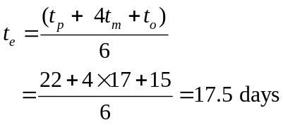
Hence, option (C) is correct.
Q.14. A project comprises three activities as per the details provided in the table.

Activity | Duration (days) |  |  | Immediate Predecessor
Activity | Optimistic | Most likely | Pessimistic | Immediate Predecessor
A | 12 | 15 | 21 | -------
B | 22 | 30 | 41 | A
C | 17 | 20 | 26 | B
The expected time for project completion and its standard deviation (in days) are
(A) 65, 4 (B) 65, 16 (C) 66.5, 14.53 (D) 66.5, 3.81
Sol. The expected activity time (t_{e}) is calculated as
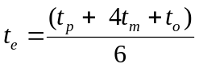
where t_{p}, t_{m} and t_{o} are pessimistic, most likely and optimistic time, respectively. The variance (σ²) is calculated as
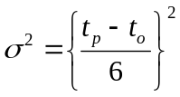
Standard deviation is calculated as
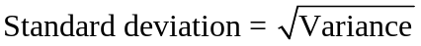
Expected time and variance of each activity are provided in table.
Activity | Duration (days) |  |  | Expected time (t_{e}) | Variance
Activity | Optimistic | Most likely | Pessimistic | Expected time (t_{e}) | Variance
A | 12 | 15 | 21 | 15.5 | 2.25
B | 22 | 30 | 41 | 30.5 | 10.03
C | 17 | 20 | 26 | 20.5 | 2.25

Project expected time = 15.5+30.5+20.5=66.5 days
Project Variance = 2.25+10.03+2.25=14.53
Standard deviation = 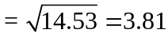
Hence, option (D) is correct.
Q.15. PERT was initially introduced to satisfy the demands of U.S. Navy by
(A) Booz-Allen and Hamilton
(B) Boston Consulting Group
(C) Deloitte
(D) McKinsey & Company
Sol. PERT was introduced by the consulting firm “Booz-Allen and Hamilton” in the 1950s to satisfy the demands of the U.S. Navy Special Projects Office. Hence, option (A) is correct.
Q.16. Expected time of the completion of a project is 10 days. Project will start on October 1, 2026. The probability that it will be completed on October 10, 2026 is
(A) 0.99 (B) 0.95 (C) 0.25 (D) 0.5
Sol. Given,
Expected time of completion (T_{e}) = 10 days
Start date = October 1, 2026
Completion date asked = October 10, 2026
Hence, time duration for completion = 10 days
The z-score is obtained as
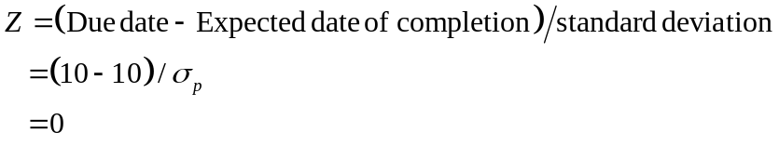
From standard normal table, or using NORMSDIST (0) command in MS excel, probability is obtained as 0.5. Hence, option (D) is correct.
Q.17. Increasing manpower for executing a project activity
(A) has no influence on the critical path
(B) has no effect on the project completion time
(C) always increases the project completion time
(D) may reduce or increase the project completion time depending on the nature of the activity
Sol. The effect of adding manpower depends on the nature of the activity. For parallel tasks, time may decrease. For highly sequential tasks, time may increase due to inefficiency or interference. Hence, option (D) is correct.
Q.18. In project management, project crashing means
(A) discontinuing a project to pursue better alternative
(B) postponing non-critical activities to control costs.
(C) reducing the project duration by allocating additional resources
(D) delaying non-critical tasks to manage budget constraints
Sol. In project management, project crashing means reducing the project duration by allocating additional resources, usually to meet a deadline or recover delay, while analysing the trade-off between time and cost. Hence, option (C) is correct.
Q.19. Consider the following statements on Critical Path Method (CPM):
(1) CPM uses probabilistic approach for time estimation
(2) CPM give three time estimates for each activity
(3) CPM is activity oriented technique
(4) CPM focuses on management of predictable activities
Which of the statements are TRUE?
(A) 1, 2 and 3 (B) 2 and 3 (C) 3 and 4 (D) 2, 3 and 4
Sol. Differences between PERT and CPM are shown in Table.
Basis of Comparison | PERT | CPM
What is it? | A technique using probabilistic approach | A technique using deterministic approach
Orientation | Event-oriented | Activity-oriented
Role in crashing | Limited | Extensive
Estimates | Three time estimates | One time estimates
Focuses on | Time | Time-cost trade-off
Management of | Unpredictable activities | Predictable activities
Hence, option (C) is correct.

Q.20. Crashing is most effective when applied to an activity that
(A) has least free float
(B) lies on the critical path
(C) has high uncertainty in its duration estimates
(D) is not on the critical path
Sol. Activities on the critical path directly determine the project completion time. Crashing these activities shortens the total project duration. Crashing non-critical activities has no effect on project duration unless they become critical later. Hence, option (B) is correct.

